🐾
PetPaws
Pet Foods & Accessories Store
MERN Stack — MongoDB · Express.js · React.js · Node.js

MERN Stack E-Commerce Application

Project Name: PetPaws — Pet Foods & Accessories Store
Project Domain: Pet Foods, Treats, Toys, Grooming & Accessories
Document Type: Project Report & Technical Documentation
Version 1.0 • 2026

INTRODUCTION
PetPaws is your one-stop destination for effortless online pet shopping. With a user-friendly interface and a comprehensive product catalog covering pet food, treats, toys, grooming products, cages, leashes, collars, beds, health supplements, and all pet-related accessories, finding the perfect items for your beloved companions has never been easier.

Seamlessly navigate through detailed product descriptions, customer reviews, and available discounts to make informed purchasing decisions. Enjoy a secure checkout process and receive instant order confirmation. For administrators, our robust dashboard provides efficient order management, insightful analytics, inventory tracking, and complete product management to drive business growth.

Experience the future of online pet shopping with PetPaws today — because your pet deserves the very best!

SCENARIO

Ravi's New Puppy
Ravi, a first-time dog owner, has just brought home a 3-month-old Labrador puppy named Bruno. Excited but overwhelmed, Ravi needs to quickly source high-quality puppy food, a collar, a leash, a bed, and some chew toys. With a hectic work schedule, Ravi turns to PetPaws to simplify his search and get everything delivered to his doorstep.

- Effortless Product Discovery: Ravi opens PetPaws and navigates to the Dog Food category. He is greeted with a diverse range of puppy nutrition options from trusted brands like Royal Canin and Pedigree. Using the filtering options, Ravi selects 'Puppy Food' under Dog Food and refines his search based on Bruno's age and weight.
- Personalized Recommendations: As Ravi scrolls through the curated selection, he notices a 'Featured Products' section. Intrigued, he clicks on it and discovers a complete starter kit. Impressed by the product ratings and verified purchase reviews, Ravi adds the Royal Canin Puppy Starter to his cart.
- Seamless Checkout Process: With the items in his cart, Ravi proceeds to checkout. He enters his delivery address, selects UPI as his preferred payment method, and completes the transaction in just a few clicks thanks to PetPaws's secure and efficient checkout process.
- Order Confirmation: Moments after placing the order, Ravi receives a confirmation notification from PetPaws with a unique order ID. He can track the real-time status of his order from the My Orders section on his profile.
- Efficient Order Management for Admin: On the admin side, the PetPaws administrator receives a notification of Ravi's purchase through the admin dashboard. They quickly update the order status to 'Confirmed' then 'Shipped', with tracking details added automatically.
- Happy Pet Parent: Within two days, Bruno's food, collar, leash, and bed arrive at Ravi's home. Bruno is thrilled with his new toys, and Ravi is delighted by the seamless experience PetPaws provided from discovery to delivery.

In this scenario, PetPaws proves to be the perfect solution for Ravi's busy lifestyle. From effortless product discovery to secure checkout and efficient order management, PetPaws simplifies the entire process — allowing new pet parents to care for their companions with confidence and ease.

SYSTEM REQUIREMENTS

1. Software Requirements
These are the essential tools and platforms required to develop, test, and run the PetPaws application efficiently.

- Operating System: Windows 10/11, macOS, or Linux — Supports cross-platform development and testing.
- Node.js (v18 or above): Provides the runtime environment for building and managing the backend API and frontend tooling.
- npm (v8 or above): A package manager required to install dependencies for React, Express, and all related libraries.
- React.js (v18): A JavaScript library for building dynamic and responsive user interfaces with component-based architecture.
- Vite (v5): A fast frontend build tool and development server used to scaffold and serve the React application.
- Express.js (v4): A lightweight web framework for building RESTful APIs in Node.js.
- MongoDB: A NoSQL database used to store data for users, products, orders, carts, reviews, and admin settings.
- Mongoose (v8): An ODM library that provides schema-based modelling for MongoDB collections.
- Axios: An HTTP client for making API requests from the React frontend to the Express backend.
- bcryptjs: For hashing and securely comparing user passwords in the authentication system.
- jsonwebtoken (JWT): For generating and verifying JSON Web Tokens used in authentication and authorization.
- Browser: Google Chrome / Firefox (latest version) — For rendering and testing the UI in real time.
- Postman: Tool for testing and documenting REST API endpoints during development.
- Visual Studio Code: Preferred code editor with built-in Git support, terminal, and extension ecosystem.
- Git & GitHub: For version control and collaborative development.

2. Hardware Requirements
Describes the minimum and recommended specifications needed to support the development and usage of the application.

- Processor: Intel Core i5 (8th Gen or above) / AMD Ryzen 5 or better — Ensures fast compilation and multitasking during development.
- RAM: Minimum 8 GB (16 GB recommended) — For handling development servers, IDEs, and browser testing simultaneously.
- Storage: At least 2 GB free space — Required for package installations, MongoDB setup, and local project files.
- Display: 1366x768 or higher — Recommended for optimal coding experience and application layout visualization.

PROJECT ARCHITECTURE

Technical Architecture
The PetPaws application follows a classic three-tier MERN stack architecture with a clear separation between the Presentation Layer (React.js), the Business Logic Layer (Node.js + Express.js), and the Data Layer (MongoDB).

In this architecture diagram:
- The Frontend is represented by the React.js section, including UI components such as Home, Products, Product Detail, Cart, Checkout, Wishlist, Profile, Orders, and the Admin Dashboard.
- The Backend is represented by the Express.js + Node.js section, consisting of API endpoints for Auth, Products, Cart, Orders, Users, Reviews, Wishlist, and Admin.
- The Database section represents MongoDB, which stores collections for Users, Products, Orders, Cart, Reviews, and AdminSettings.

FRONTEND (React.js) | BACKEND (Express.js) | DATABASE (MongoDB)
Home Page | Auth Routes & Controller | Users Collection
Products Page | Product Routes & Controller | Products Collection
Product Detail | Cart Routes & Controller | Orders Collection
Shopping Cart | Order Routes & Controller | Cart Collection
Checkout | User Routes & Controller | Reviews Collection
Wishlist | Review Routes & Controller | AdminSettings Collection
User Profile | Wishlist Controller
My Orders | Admin Controller
Admin Dashboard | JWT Middleware
Admin Products | Error Handler

ER Diagram Overview
The PetPaws ER diagram represents the entities and relationships involved in the pet e-commerce system. It illustrates how users, products, cart, orders, and reviews are interconnected.

- USER: Represents the individuals registered on the platform. Contains fields for username, email, password, phone, avatar, role (user/admin), addresses array, wishlist array, and active status.
- Admin: Represents the AdminSettings collection with important details such as banner images, product categories, shipping fees, and tax configuration.
- Products: Represents the collection of all pet products available on the platform — food, toys, accessories, grooming items, health supplements, and more.
- Cart: Stores all products added to cart by users. Each cart is differentiated by userId and contains an array of items with product reference, quantity, price, and variant.
- Orders: Stores all orders made by users, including order items, shipping address, payment details, order status history, and tracking information.
- Reviews: Stores user-submitted product reviews including star rating, title, comment, and verified purchase status.

FEATURES
PetPaws delivers a comprehensive and feature-rich e-commerce experience tailored specifically for pet owners and pet product administrators.

- Comprehensive Pet Product Catalog: PetPaws boasts an extensive catalog covering Dog Food, Cat Food, Bird Food, Fish Food, Toys, Grooming products, Accessories, Health Supplements, Beds, Cages, Leashes, Collars, and Clothing. Each product has detailed descriptions, images, brand info, weight/size variants, and pet-type filtering.
- Advanced Product Search & Filters: Users can search by keyword and apply multiple filters simultaneously — category, pet type (Dog, Cat, Bird, Fish, etc.), price range, brand, minimum rating, and sort options (Newest, Popular, Top Rated, Price Low-High, Price High-Low) — with paginated results.
- Add to Cart & Wishlist: Each product listing features convenient 'Add to Cart' and 'Add to Wishlist' buttons. Users can update quantities, remove items, move from wishlist to cart, and the cart displays real-time totals with shipping calculations.
- Multi-Step Secure Checkout: PetPaws provides a 3-step checkout process: (1) Shipping Address with saved address selection, (2) Payment Method selection (COD, Card, UPI, Net Banking), and (3) Order Review before final placement. Stock is validated before order creation.
- Order Confirmation & Tracking: After placing an order, users receive an instant confirmation with their Order ID. A visual status timeline (Pending → Confirmed → Processing → Shipped → Delivered) is shown on the Order Detail page along with tracking numbers.
- Product Reviews & Ratings: Customers can submit star ratings (1-5), a review title, and detailed comments. Verified Purchase badges are automatically applied for users who have received the product. Average ratings are recalculated dynamically.
- User Profile & Address Management: Users can update their profile (name, phone), change password securely, and manage multiple saved delivery addresses with a default address designation for faster checkout.
- Robust Admin Dashboard: Administrators get a data-rich dashboard showing total revenue, order count, customer count, product count, monthly revenue bar chart, top-selling products, recent orders, and low-stock alerts.
- Admin Product Management: Admins can create, edit, delete (soft delete), and search products with full control over all fields including category, pet type, price, discount, stock, images, variants, tags, and featured status.
- Admin Order Management: Admins can view all orders with status filter tabs, update order status through the full lifecycle, add tracking numbers, and add internal notes for each status change.
- Admin Customer Management: Admins can view all registered customers, search by name or email, and activate/deactivate user accounts as needed.
- Store Settings Management: Admins can configure shipping fees, free shipping thresholds, tax rates, store name, tagline, contact details, homepage banners, and product category definitions.

ROLES AND RESPONSIBILITIES

USER
Represents the individuals or entities who are registered on the PetPaws platform as pet owners or shoppers.
- Can browse, search, and filter all available pet products.
- Can add products to the shopping cart and wishlist.
- Can complete the checkout process with address and payment details.
- Can view order history, track order status, and cancel eligible orders.
- Can submit product reviews and ratings.
- Can manage their personal profile, password, and multiple delivery addresses.

Admin
Represents the platform administrator who manages all store operations through the Admin Dashboard.
- Can log into the dedicated admin panel with elevated access.
- Can create, edit, and remove pet product listings.
- Can manage product categories, banner images, and site settings.
- Can view and update the status of all customer orders.
- Can monitor inventory levels and receive low-stock alerts.
- Can view all registered customers and manage their account status.
- Can access dashboard analytics including revenue charts and top products.

Products
Represents the collection of all pet products available on the platform, including food, accessories, toys, and health products.

Cart
Stores all products added to the cart by individual users. Each cart is differentiated by the user ID and maintains item-level quantity tracking with real-time price computation.

Orders
Stores all orders placed by users on the platform, including full order item details, shipping address, payment method, status history, and delivery tracking.

User Flow
- Users start by registering for an account with username, email, and password.
- After registration, they can log in with their credentials and receive a JWT token.
- Once logged in, they can browse all available pet products with advanced filters.
- Users can add products to the cart and wishlist from the product listing or detail pages.
- They then proceed through the 3-step checkout: Address → Payment → Review & Confirm.
- After ordering, they can track their orders in real time from the My Orders section.
- Users can submit product reviews after receiving delivered orders.

MVC PATTERN
The PetPaws backend application follows the Model-View-Controller (MVC) architectural pattern, a software design approach that separates the application into three interconnected layers. This separation allows for modularity, easier maintenance, and scalability.

Model Layer (Data Layer)
The Model layer is responsible for handling all data-related logic. This includes the definition of data schemas and the operations performed on the database using those schemas. The models are implemented using Mongoose, which provides a schema-based solution to model application data for MongoDB.

PetPaws defines the following Mongoose models:
- User Model: Handles user registration data, password hashing, address management, wishlist, and role assignment.
- Product Model: Stores all pet product data including category, petType, variants, pricing, stock, and ratings.
- Order Model: Manages the full order lifecycle from creation to delivery with status history tracking.
- Cart Model: Maintains per-user cart state with product references, quantities, and prices.
- Review Model: Stores product reviews with ratings, verified purchase flags, and approval status.
- Admin Model: Stores site-wide configuration including banners, categories, and business settings.

Controller Layer
The Controller layer acts as an intermediary between the routes and the models. It receives incoming requests, processes the input (including validation or transformation), calls the appropriate methods from the model, and then returns a response to the client.

PetPaws controllers include:
- authController.js — Handles user registration, login, admin login, and token validation.
- productController.js — Manages product CRUD, featured products, related products, brand listing, and search.
- cartController.js — Handles adding items, updating quantities, removing items, and clearing the cart.
- orderController.js — Manages order creation, user order history, admin order listing, and status updates.
- userController.js — Handles profile updates, password changes, and address management.
- reviewController.js — Manages product review submission, listing, and deletion.
- wishlistController.js — Handles toggling wishlist items and moving items to cart.
- adminController.js — Provides dashboard statistics, settings management, and banner control.

View Layer (Routing Layer)
In the context of a backend REST API, the View is implemented as the routing layer, where various endpoints are defined. These endpoints determine how the backend responds to different HTTP requests (GET, POST, PUT, DELETE) and are responsible for invoking the appropriate controller functions.

Advantages of Using MVC in This Project
- Separation of Concerns: Each layer has a clearly defined responsibility, improving readability and maintainability.
- Scalability: New features can be added easily by creating new routes, controllers, and models.
- Reusability: Logic in controllers and models can be reused across multiple parts of the application.
- Testing: Each layer can be tested independently, especially controllers and models.
- Collaboration-Friendly: Multiple developers can work simultaneously on different layers without conflict.

PROJECT SETUP AND CONFIGURATION

Creating the Project Folder
- Create a new folder named petpaws.
- Inside that folder, create two sub-folders.
- Name one client.
- Name the other server.
- Now open the petpaws folder in VS Code.

Client Setup (Installing React App)
- Open the client folder in the terminal of VS Code.

npm create vite@latest . -- --template react

- Select React framework from the given options:
Select a framework:
│ React

- Select JavaScript variant from the given options:
Select a variant:
│ JavaScript

- Navigate to the client folder:
cd client

- To install all the packages, run:
npm install

- Install additional required libraries:
npm install axios react-router-dom react-hot-toast react-icons

- To start the React development server:
npm run dev

Server Setup (npm init)
- Open the server folder in the terminal of VS Code.

npm init -y

- Install server dependencies:
npm install express mongoose bcryptjs jsonwebtoken cors dotenv multer
npm install --save-dev nodemon

- Create the following files and folder structure:
server/
├── index.js
├── .env
├── config/
│ └── db.js
├── models/
│ ├── User.js
│ ├── Product.js
│ ├── Order.js
│ ├── Cart.js
│ ├── Review.js
│ └── Admin.js
├── controllers/
│ ├── authController.js
│ ├── productController.js
│ ├── cartController.js
│ ├── orderController.js
│ ├── userController.js
│ ├── reviewController.js
│ ├── wishlistController.js
│ └── adminController.js
├── routes/
│ ├── authRoutes.js
│ ├── productRoutes.js
│ ├── cartRoutes.js
│ ├── orderRoutes.js
│ ├── userRoutes.js
│ ├── reviewRoutes.js
│ ├── wishlistRoutes.js
│ └── adminRoutes.js
├── middleware/
│ └── auth.js
└── data/
└── seeder.js

BACKEND DEVELOPMENT

1. Setup Express Server
- Create index.js as the application entry point.
- Create an Express server on port 8000.
- Configure CORS middleware to allow requests from the React frontend (port 5173).
- Define and mount all API routes.

// index.js
const express = require('express');
const cors = require('cors');
const dotenv = require('dotenv');
dotenv.config();
connectDB();
const app = express();
app.use(cors({ origin: 'http://localhost:5173', credentials: true }));
app.use(express.json({ limit: '10mb' }));
app.listen(process.env.PORT || 8000);

2. Database Configuration
- Set up MongoDB either locally or using MongoDB Atlas cloud service.
- Create a config/db.js file to manage the Mongoose connection.
- Define the .env file with the MongoDB connection string.

// config/db.js
const mongoose = require('mongoose');
const connectDB = async () => {
const conn = await mongoose.connect(process.env.MONGO_URI);
console.log('MongoDB Connected: ' + conn.connection.host);
};
module.exports = connectDB;

3. Create Express.js Server
- Set up an Express.js server to handle HTTP requests and serve API endpoints.
- Configure middleware including body-parser equivalent (express.json) and cors.
- Mount all route modules under the /api prefix.

4. Define API Routes
- Create separate route files for each API domain: auth, products, cart, orders, users, reviews, wishlist, admin.
- Define necessary routes for product listing, user authentication, order management, and admin operations.
- Implement route handlers using Express.js to handle requests and interact with the database.

Route Module | Endpoints
/api/auth | POST /register, POST /login, POST /admin/login, GET /me
/api/products | GET /, GET /featured, GET /brands, GET /:id, GET /:id/related, POST /, PUT /:id, DELETE /:id
/api/cart | GET /, POST /, PUT /:itemId, DELETE /:itemId, DELETE /
/api/orders | POST /, GET /my, GET /:id, PUT /:id/cancel, GET / (admin), PUT /:id/status
/api/users | PUT /profile, PUT /password, POST /addresses, PUT /addresses/:id, DELETE /addresses/:id
/api/reviews | POST /, GET /product/:productId, DELETE /:id
/api/wishlist | GET /, POST /:productId, DELETE /:productId
/api/admin | GET /dashboard, GET /settings, PUT /settings, POST /banners, DELETE /banners/:id

5. Implement Data Models
- Define Mongoose schemas for User, Product, Order, Cart, Review, and AdminSettings.
- Create corresponding Mongoose models to interact with the MongoDB database.
- Implement CRUD operations for each model.

6. User Authentication
- Create routes and controllers for user registration, login, and admin login.
- Hash passwords using bcryptjs before saving to database.
- Generate JWT tokens on successful login for session management.
- Set up authentication middleware (auth.js) to protect private routes.

// middleware/auth.js — protect middleware
const protect = async (req, res, next) => {
const token = req.headers.authorization?.split(' ')[1];
const decoded = jwt.verify(token, process.env.JWT_SECRET);
req.user = await User.findById(decoded.id).select('-password');
next();
};
const adminOnly = (req, res, next) => {
if (req.user?.role === 'admin') next();
else res.status(403).json({ message: 'Admin access required' });
};

7. Handle Products and Orders
- Create routes and controllers to handle pet product listings, including filtering by category, petType, brand, price range, and keyword search with MongoDB text indexing.
- Implement the ordering functionality with stock validation, automatic discount price calculation, shipping fee computation, and tax calculation.
- After order placement, automatically deduct product stock and increment soldCount.

8. Admin Functionality
- Implement routes and controllers for admin-specific operations including product CRUD, order status management, user management, and store settings.
- Add authentication (protect) and authorization (adminOnly) middleware to all admin routes.
- Implement the admin dashboard endpoint that aggregates revenue, order counts, top products, and low-stock alerts using MongoDB aggregation pipelines.

9. Error Handling
- Implement global error handling middleware to catch and handle all errors during API requests.
- Return appropriate HTTP status codes (400, 401, 403, 404, 500) with descriptive error messages.
- All controllers are wrapped in try-catch blocks to handle database and validation errors gracefully.

DATABASE DEVELOPMENT

Schema Use-Case

1. User Schema
- Schema: userSchema
- Model: 'User'
- The User schema represents user data and includes fields for username, email, password, phone, avatar, role, addresses array, wishlist array, and active status.
- It is used to store user information for registration, authentication, and profile management.
- The email field is marked as unique to ensure each user has a unique email address.
- Passwords are hashed using bcryptjs via a pre-save middleware hook before storing in MongoDB.
- A comparePassword instance method is defined for secure authentication.

const userSchema = new mongoose.Schema({
username: { type: String, required: true, trim: true },
email: { type: String, required: true, unique: true, lowercase: true },
password: { type: String, required: true, minlength: 6, select: false },
phone: { type: String, default: '' },
role: { type: String, enum: ['user', 'admin'], default: 'user' },
addresses: [addressSchema],
wishlist: [{ type: mongoose.Schema.Types.ObjectId, ref: 'Product' }],
isActive: { type: Boolean, default: true },
}, { timestamps: true });

2. Product Schema
- Schema: productSchema
- Model: 'Product'
- The Product schema represents all pet products available on the platform including food, toys, accessories, and health supplements.
- Key fields include: name, description, price, discountedPrice, discount (%), category, petType (array), brand, images, stock, weight, variants, ratings, tags, isFeatured, isActive, and soldCount.
- A text search index is created on name, description, brand, and tags fields for keyword search functionality.
- A pre-save hook automatically computes the discountedPrice from the base price and discount percentage.

const productSchema = new mongoose.Schema({
name: { type: String, required: true },
price: { type: Number, required: true, min: 0 },
discount: { type: Number, default: 0, min: 0, max: 100 },
category: { type: String, required: true, enum: [15 categories] },
petType: { type: [String], enum: ['Dog','Cat','Bird','Fish',...] },
stock: { type: Number, required: true, min: 0 },
ratings: { average: Number, count: Number },
isFeatured: { type: Boolean, default: false },
}, { timestamps: true });

3. Orders Schema
- Schema: orderSchema
- Model: 'Order'
- The Order schema stores complete order data including: user reference, order items array (product, name, image, price, quantity, variant), shipping address, payment method and status, pricing breakdown (items, shipping, tax, total), and order status with history.
- The statusHistory field is an array tracking every status change with timestamp and note.
- The orderStatus field follows the lifecycle: Pending → Confirmed → Processing → Shipped → Delivered (or Cancelled/Returned).

const orderSchema = new mongoose.Schema({
user: { type: ObjectId, ref: 'User', required: true },
orderItems: [orderItemSchema],
shippingAddress: shippingAddressSchema,
paymentMethod: { type: String, enum: ['COD','Card','UPI','NetBanking'] },
totalPrice: { type: Number, required: true },
orderStatus: { type: String, default: 'Pending' },
statusHistory: [{ status, timestamp, note }],
}, { timestamps: true });

4. Cart Schema
- Schema: cartSchema
- Model: 'Cart'
- The Cart schema stores the shopping cart data for each user including: user reference (one cart per user), items array (product ref, name, image, price, quantity, variant, stock), and optional coupon/discount fields.
- Each user has exactly one cart document. Items are added/updated/removed in place.

const cartSchema = new mongoose.Schema({
user: { type: ObjectId, ref: 'User', unique: true },
items: [{
product: { type: ObjectId, ref: 'Product' },
name: String,
price: Number,
quantity: { type: Number, min: 1, default: 1 },
variant: { type: String, default: '' },
}],
}, { timestamps: true });

5. Admin Schema
- Schema: adminSettingsSchema
- Model: 'AdminSettings'
- The Admin schema stores site-wide configuration including: banner images for the homepage carousel, product category definitions with icons and subcategories, shipping fee, free shipping threshold, tax rate, store name, tagline, and contact information.

const adminSettingsSchema = new mongoose.Schema({
banners: [bannerSchema],
categories: [categorySchema],
shippingFee: { type: Number, default: 50 },
freeShippingAbove: { type: Number, default: 500 },
taxRate: { type: Number, default: 5 },
siteName: { type: String, default: 'PetPaws' },
}, { timestamps: true });

6. Review Schema
- Schema: reviewSchema
- Model: 'Review'
- The Review schema stores customer product reviews with: user and product references, rating (1-5), title, comment, helpful votes array, isVerifiedPurchase flag (set automatically based on delivery status), and isApproved status.
- A compound unique index on (user, product) ensures each user can review a product only once.

FRONT-END DEVELOPMENT

1. Setup React Application
- Create a React app in the client folder using Vite.
- Install required libraries: axios, react-router-dom, react-hot-toast, react-icons.
- Configure the Vite proxy to forward /api requests to the backend (port 8000).
- Create the following page and component structure:

client/src/
├── App.jsx — Root component with all route definitions
├── main.jsx — React DOM render entry point
├── index.css — Global CSS with design tokens (CSS variables)
├── context/
│ ├── AuthContext.jsx — Global auth state (user, login, logout, updateUser)
│ └── CartContext.jsx — Global cart state (cart, addToCart, updateItem, ...)
├── utils/
│ └── api.js — Axios instance + all API function exports
├── components/
│ ├── Common/ — Navbar, Footer, ProductCard
│ └── Admin/ — AdminLayout (sidebar + topbar)
└── pages/
├── Auth/ — Login, Register
├── User/ — Home, Products, ProductDetail, Cart,
│ Checkout, OrderConfirmation, Orders,
│ OrderDetail, Profile, Wishlist
└── Admin/ — Dashboard, AdminProducts, AdminProductForm,
AdminOrders, AdminOrderDetail, AdminUsers,
AdminSettings

2. Design UI Components
- Navbar: Sticky top navigation with PetPaws logo, full-text search form, wishlist icon, animated cart badge, user dropdown with profile/orders/admin links, and a category quick-link bar beneath.
- Footer: 4-column layout with brand info, quick links, customer links, and contact details on a dark background.
- ProductCard: Hover-animated card with discount badge, out-of-stock overlay, quick Add to Cart and Wishlist hover buttons, star rating display, price with strikethrough original, and low-stock alert.
- AdminLayout: Collapsible sidebar with dark theme navigation (Dashboard, Products, Orders, Customers, Settings), sticky topbar with admin user avatar, and a content area outlet.

3. Implement Frontend Logic
Integration with API Endpoints:
- All API calls are made through the centralized api.js utility which uses Axios with an interceptor to automatically attach the JWT Authorization header from localStorage.
- A response interceptor handles 401 Unauthorized errors globally by clearing the token and redirecting to the login page.
- Named API groups (authAPI, productAPI, cartAPI, orderAPI, userAPI, wishlistAPI, reviewAPI, adminAPI) are exported for clean, module-level usage across all components.

Implement Context Providers:
- AuthContext: Provides global user state initialized from localStorage. Exposes login(), logout(), and updateUser() functions. On mount, validates the stored token by calling GET /api/auth/me.
- CartContext: Provides global cart state with addToCart(), updateItem(), removeItem(), clearCart() functions. Re-fetches the cart whenever the user state changes. Exposes computed cartCount and cartTotal.

Route Protection:
- A ProtectedRoute component wraps private routes, checking auth state and redirecting unauthenticated users to the login page.
- An adminOnly prop on ProtectedRoute additionally checks user role and redirects non-admins to the homepage.

PROJECT EXECUTION

Steps for Project Execution

STEP 1: SET UP THE FRONTEND (REACT APP)

a) Open a terminal and navigate into the client folder:
cd client

b) Install all required dependencies:
npm install

c) Start the React development server:
npm run dev

d) The app should now be running on:
http://localhost:5173

STEP 2: SET UP THE BACKEND (EXPRESS SERVER)

a) Open a new terminal tab/window.
b) Navigate into the server folder:
cd server

c) Install all server dependencies:
npm install

STEP 3: CONFIGURE ENVIRONMENT VARIABLES

a) Inside the server folder, create a new file named .env
b) Add the following configuration to the .env file:

PORT=8000
MONGO_URI=mongodb://localhost:27017/petpaws
JWT_SECRET=petpaws_super_secret_jwt_key_2024
JWT_EXPIRE=7d
NODE_ENV=development

STEP 4: SEED THE DATABASE

a) Run the database seeder to populate sample data:
npm run seed

This will create:
- Admin Account: admin@petpaws.com / admin123
- Test User Account: john@example.com / user123
- 16 sample pet products across all categories
- Sample delivered order for the test user
- Homepage banner and category configuration

STEP 5: START THE BACKEND SERVER

a) Start the backend with nodemon for hot-reload:
npm run dev

b) Or for production:
npm start

c) The backend server starts on:
http://localhost:8000

d) Verify the API is running:
http://localhost:8000/api/health

OUTPUT SCREENSHOTS
The following describes each page of the PetPaws application as it appears to the end user and administrator.

Landing Page
The PetPaws homepage features a full-width animated hero section with a rotating carousel of 3 slides (Pet Food Sale, Grooming Essentials, Cat Products) with floating emoji animations. Below is a trust badges strip (Free Shipping, Genuine Products, Top Rated, Easy Returns), a Shop by Category grid (8 pet categories with emoji icons), a Featured Products grid, a Shop by Pet Type banner row, and a CTA signup section.
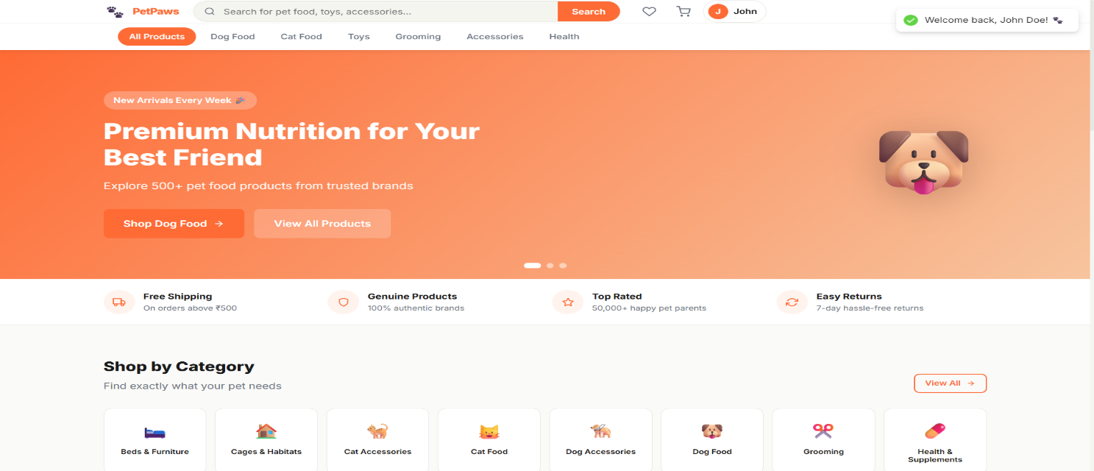
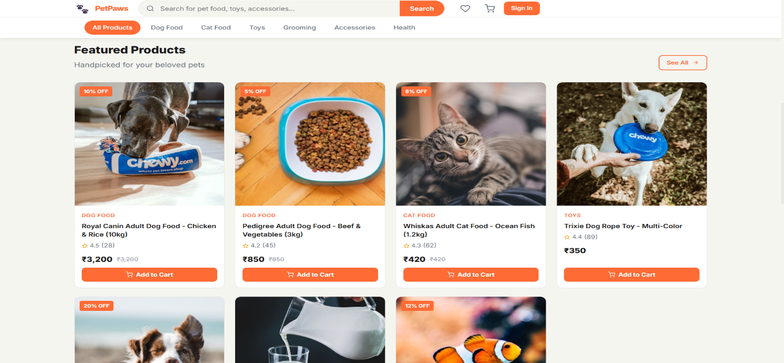
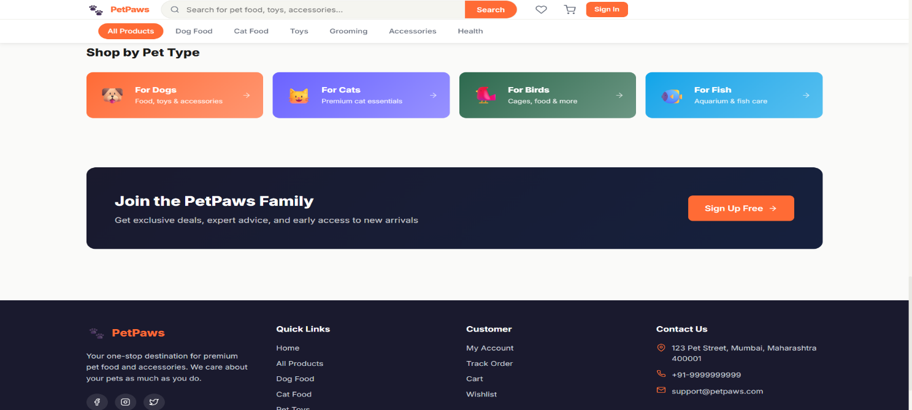

Products Page
The Products page displays a responsive product grid with a collapsible sidebar filter panel. Filters include: Category radio list, Pet Type radio list, Price Range with quick-select buttons (Under ₹500, ₹500-₹1000, ₹1000-₹2500, ₹2500+). Products are displayed with a sort dropdown (Newest, Popular, Top Rated, Price Low-High, Price High-Low) and numbered pagination controls at the bottom.
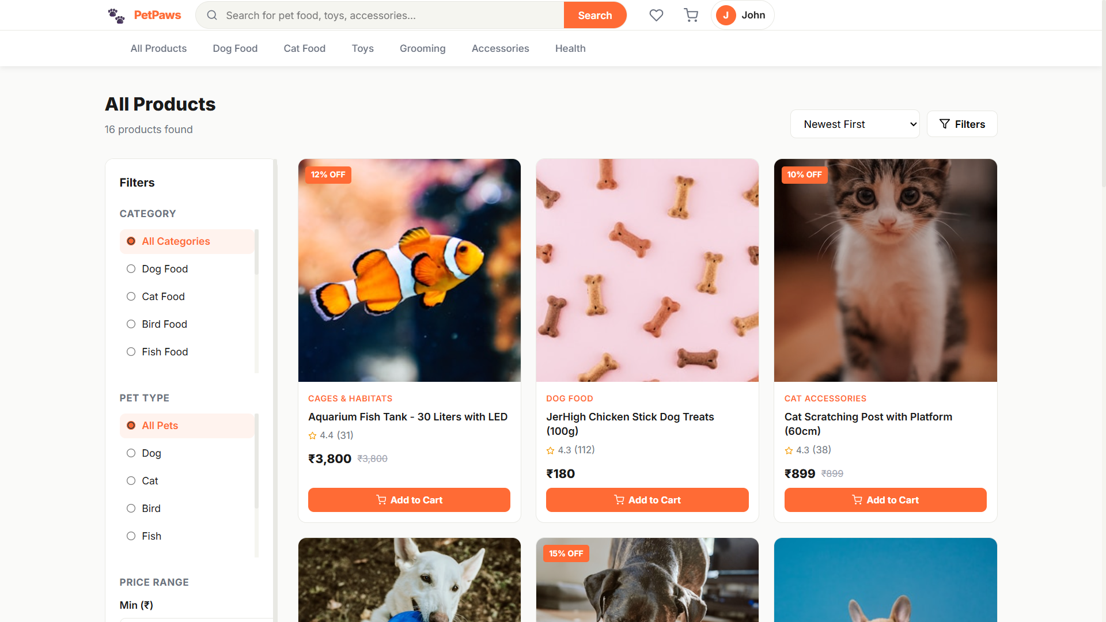
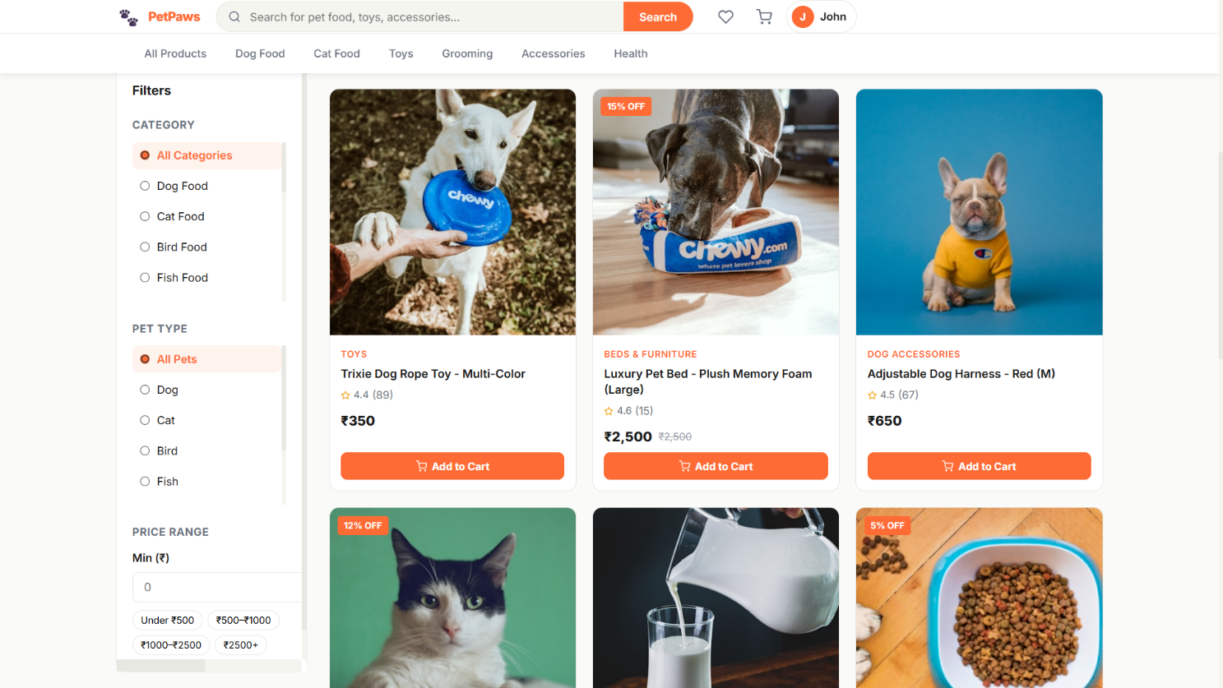

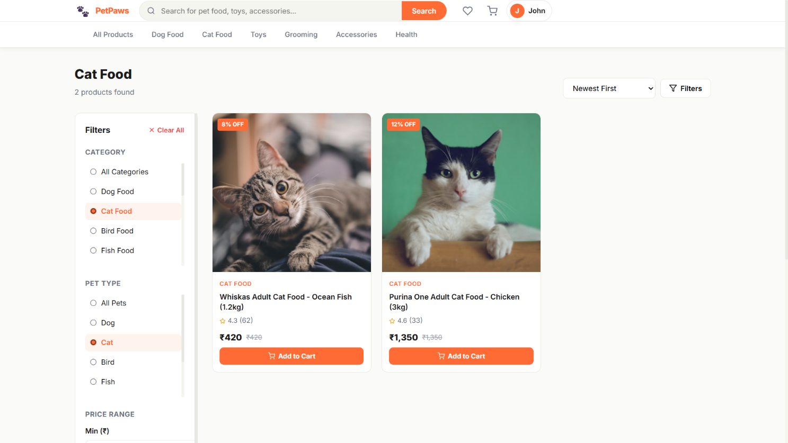

Product Detail Page
The product detail page shows a square main image with thumbnail strip, discount badge, out-of-stock overlay, brand and category info, star rating display, price with savings badge, stock status indicator, variant size/weight selector buttons, quantity stepper, Add to Cart + Buy Now + Wishlist action row, delivery info box, and product tags. A tabbed section below shows Description and Reviews (with a write-review form for logged-in users).
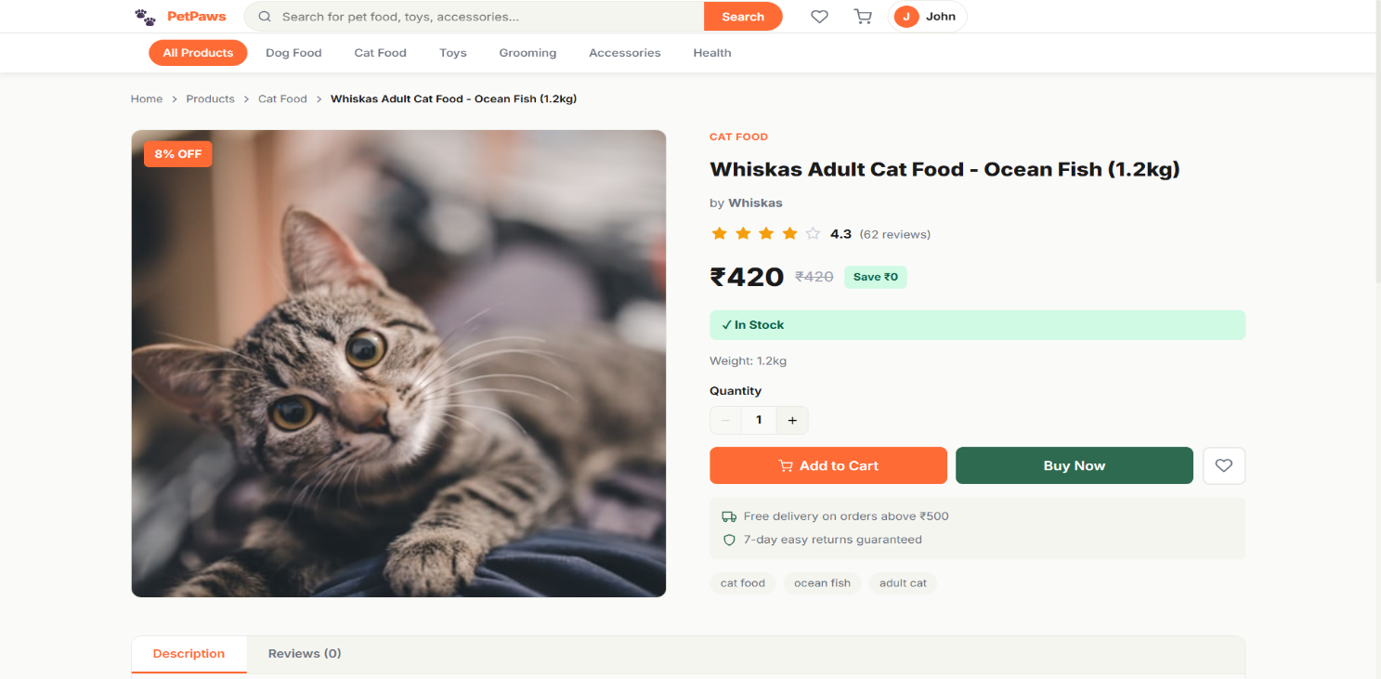
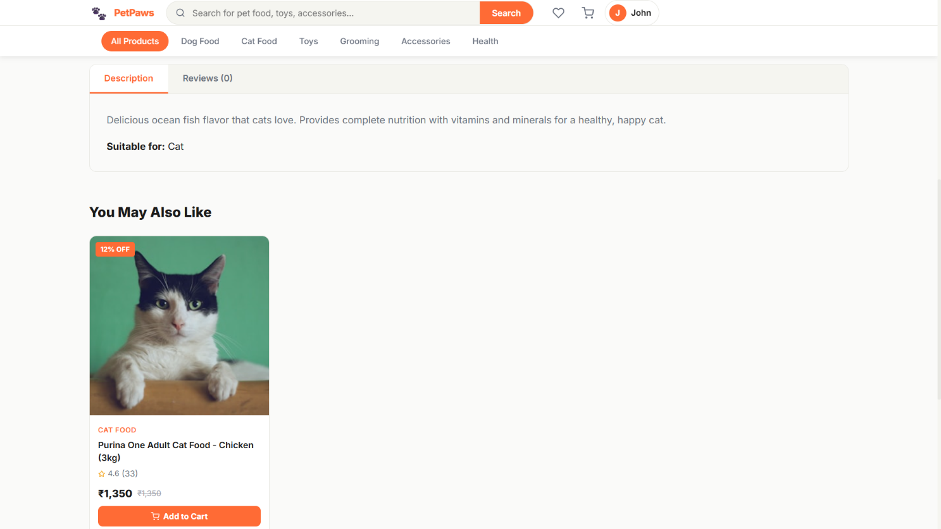

Authentication Pages
The Registration page is a centered card with the PetPaws paw logo, Full Name, Email, Phone, Password (with show/hide toggle), and Confirm Password fields. The Login page adds Demo Account quick-fill buttons for Admin and User accounts for easy testing. Both pages use a gradient background matching the brand colors.
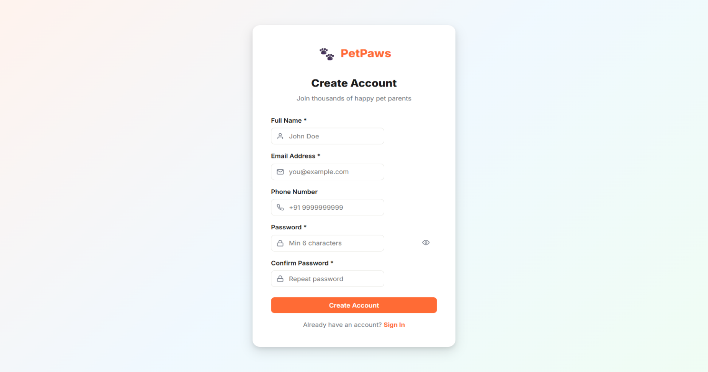
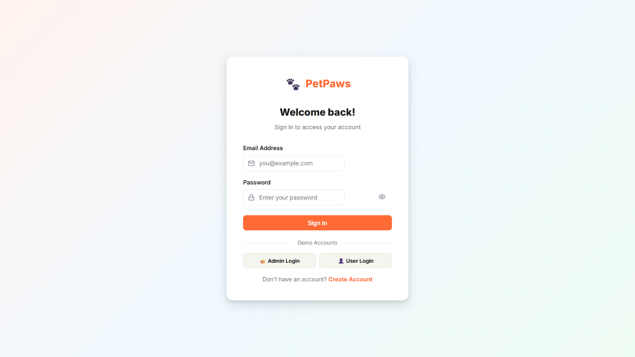

Shopping Cart
The Cart page displays a two-column layout: on the left is a product table with columns for Product (image + name + variant), Price, Quantity stepper, Total, and a Remove button. On the right is the Order Summary card showing subtotal, shipping (FREE if over ₹500), tax (5%), grand total, payment method icons, and the Proceed to Checkout button.
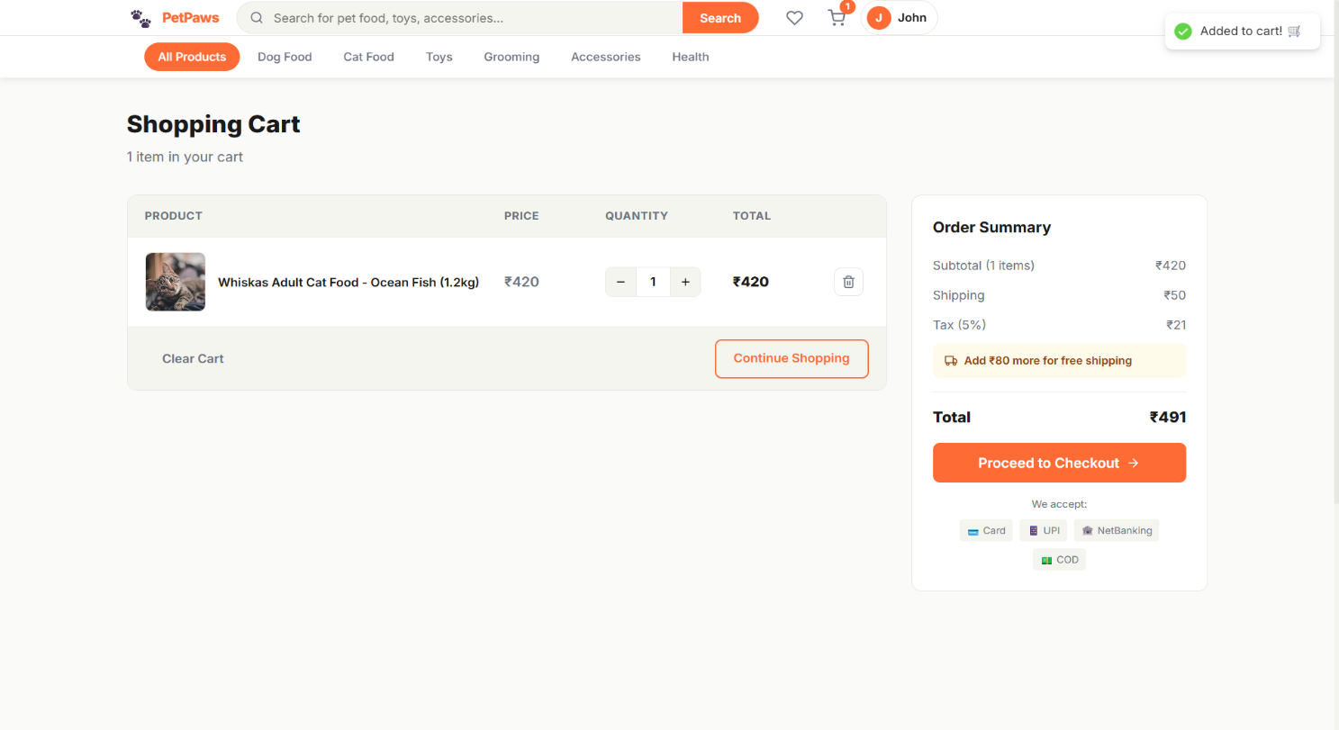

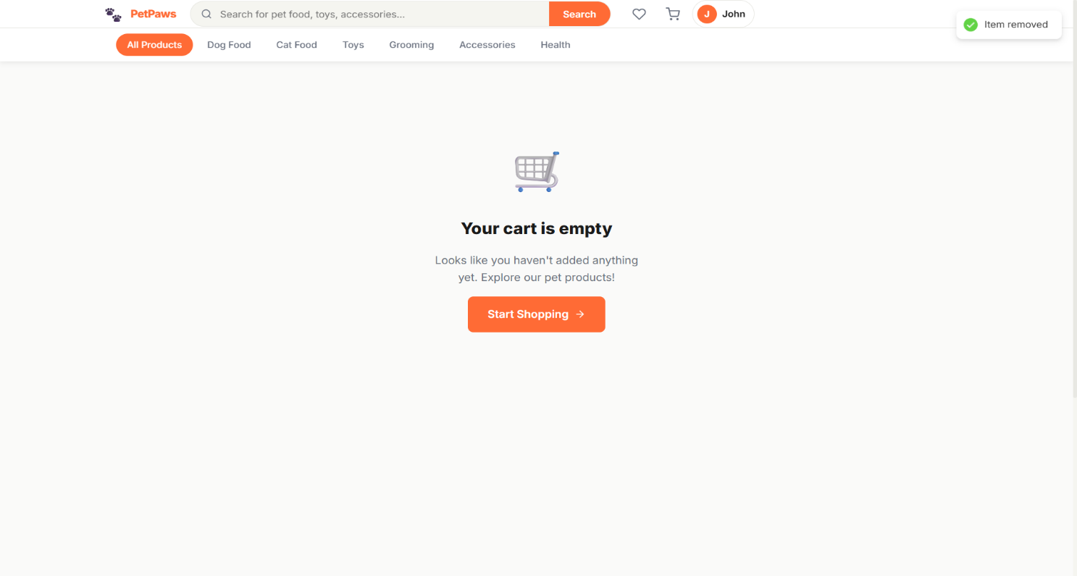

Checkout Page
The Checkout page uses a 3-step progress indicator (Shipping Address → Payment → Review Order). Step 1 shows saved address selector buttons + full address form. Step 2 shows payment method radio cards (COD, Card, UPI, Net Banking) with UPI ID input. Step 3 shows the complete order review with edit links. The right sidebar shows a persistent order summary throughout all steps.
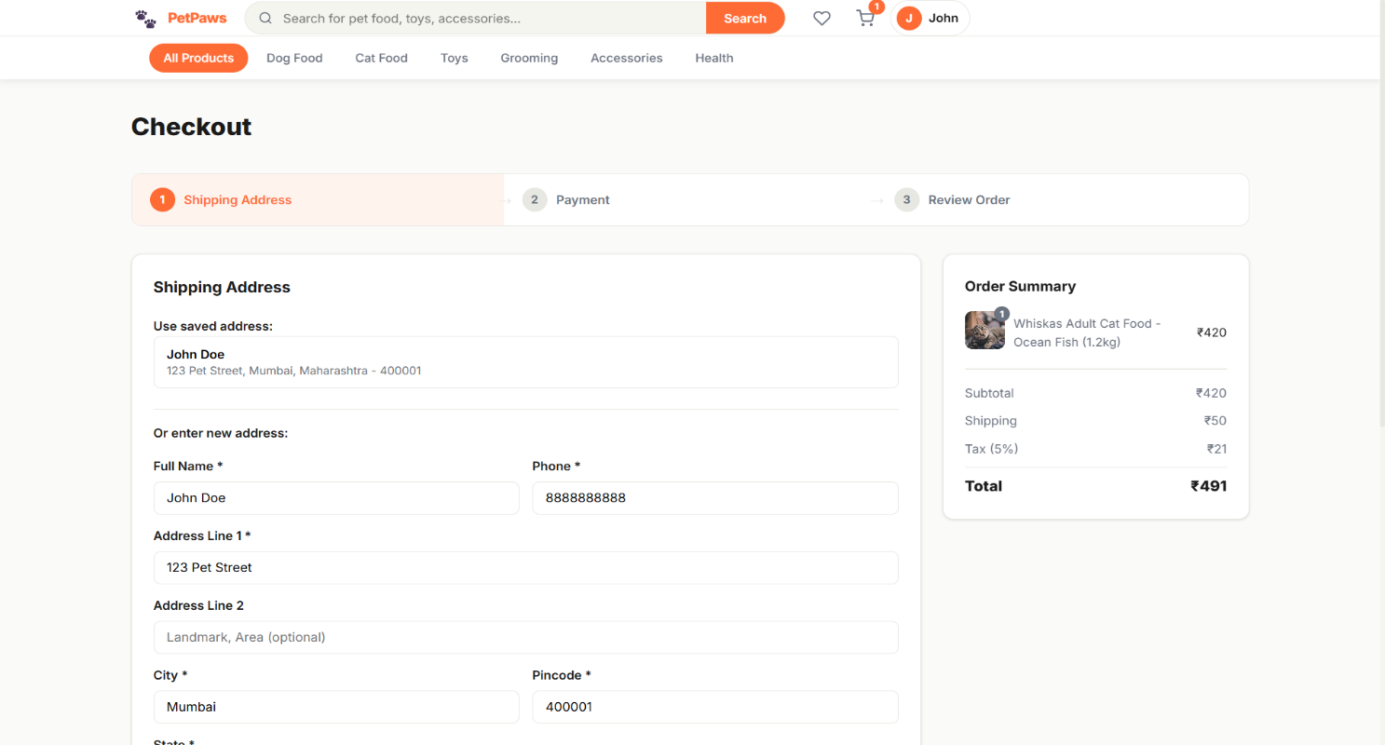

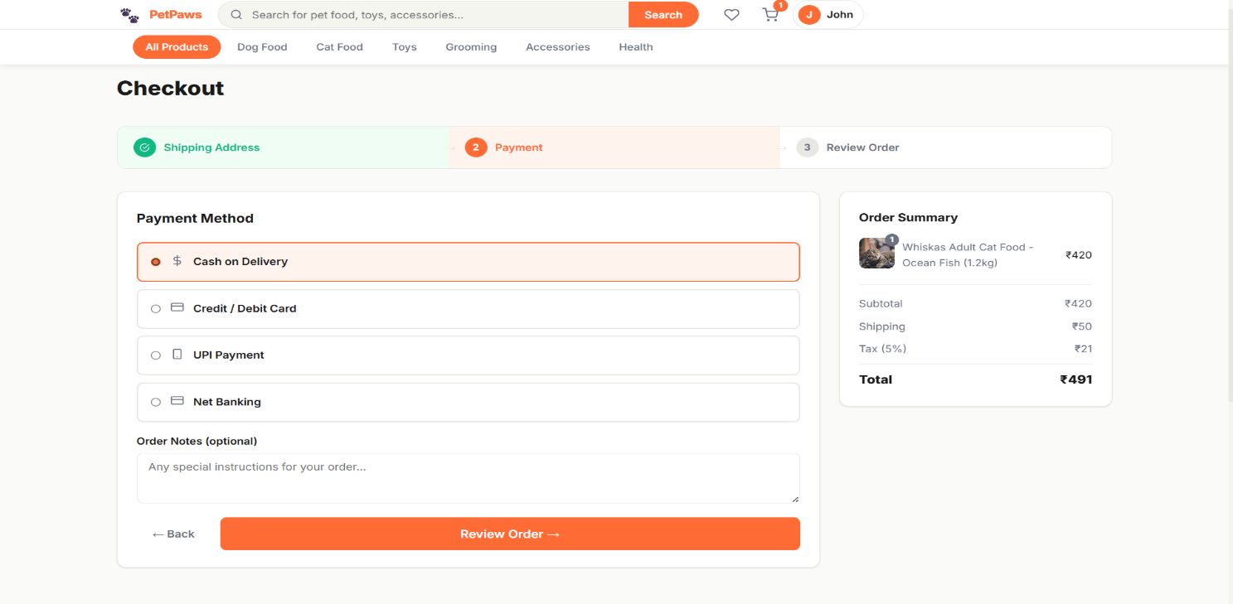

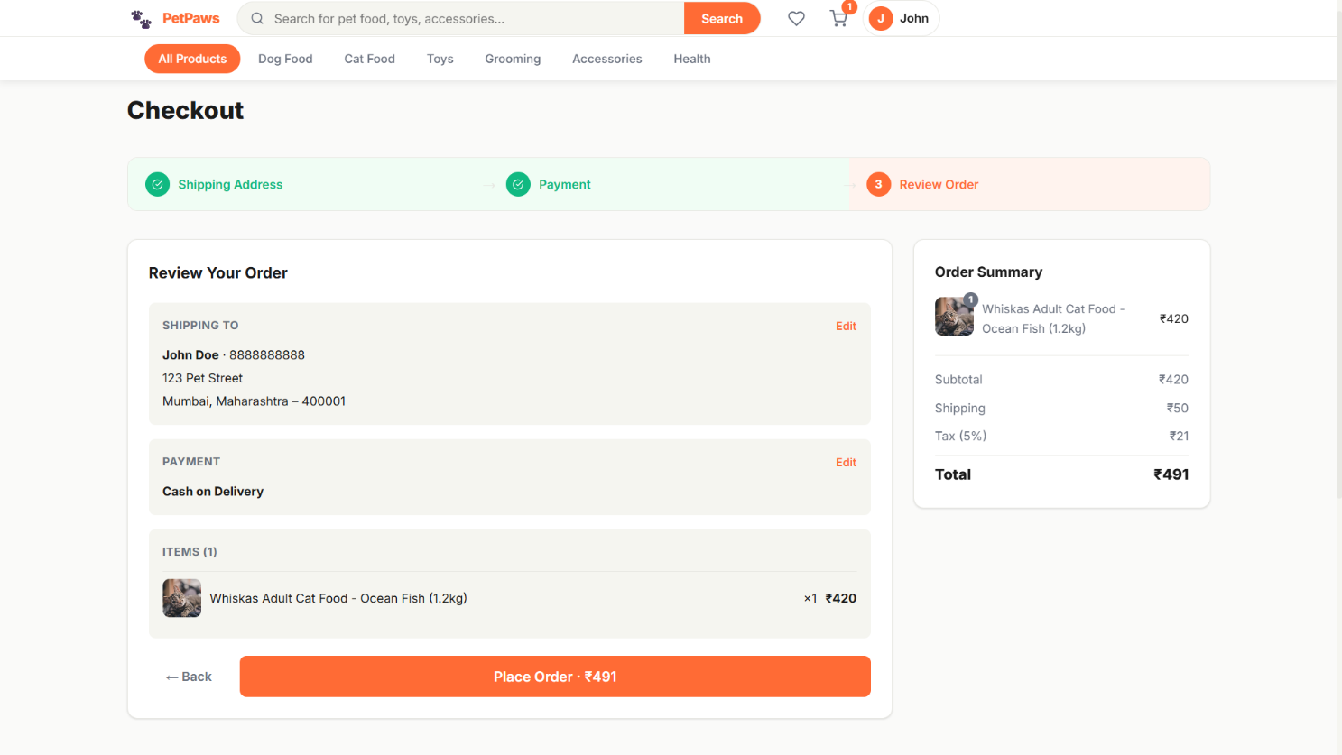

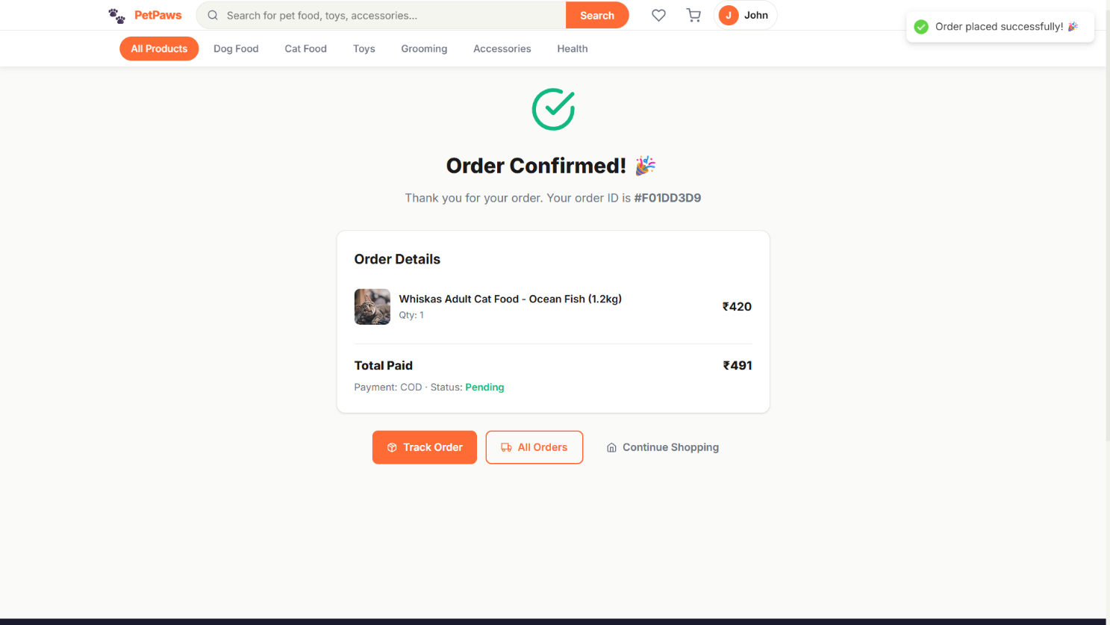

User Profile
The Profile page has a 3-tab layout: (1) Personal Information — editable name and phone fields, read-only email. (2) Password — current password + new password + confirm password with validation. (3) Addresses — saved address cards with Edit/Delete buttons and an Add Address form with full Indian state dropdown.
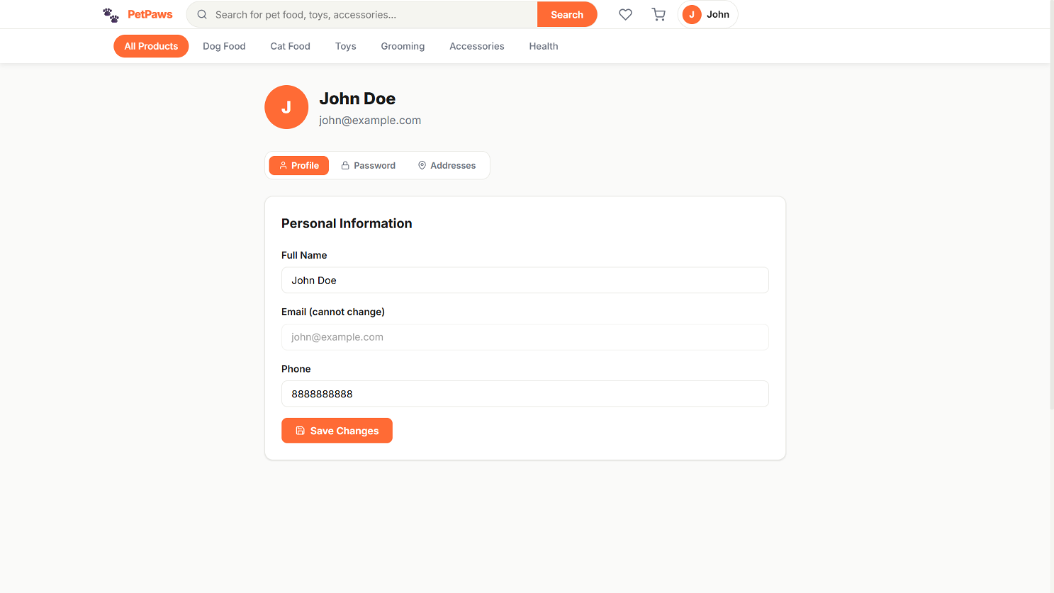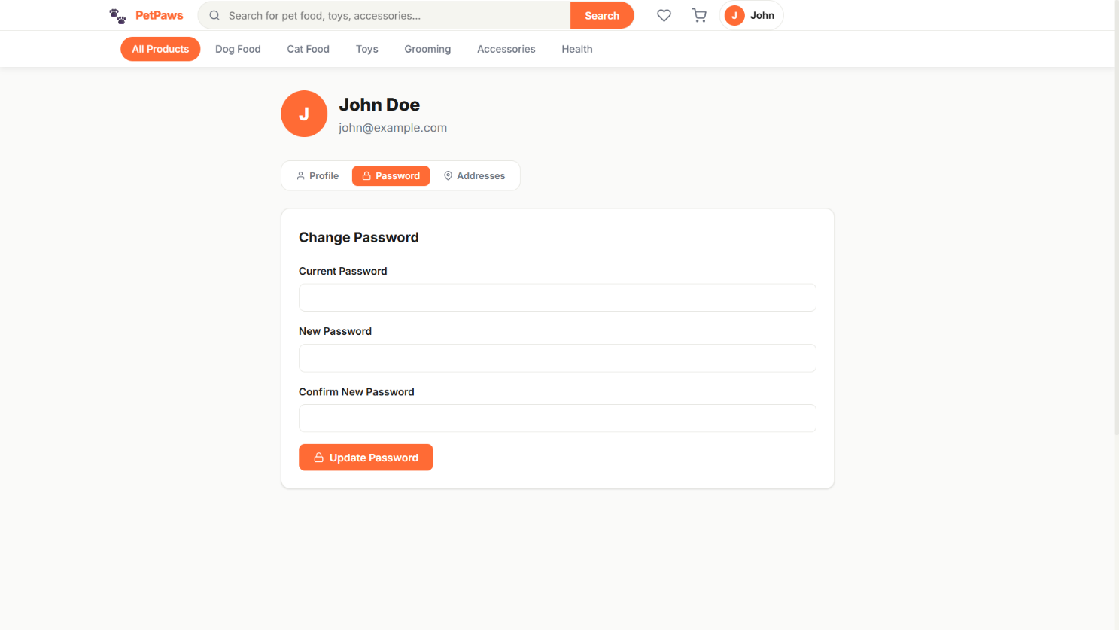
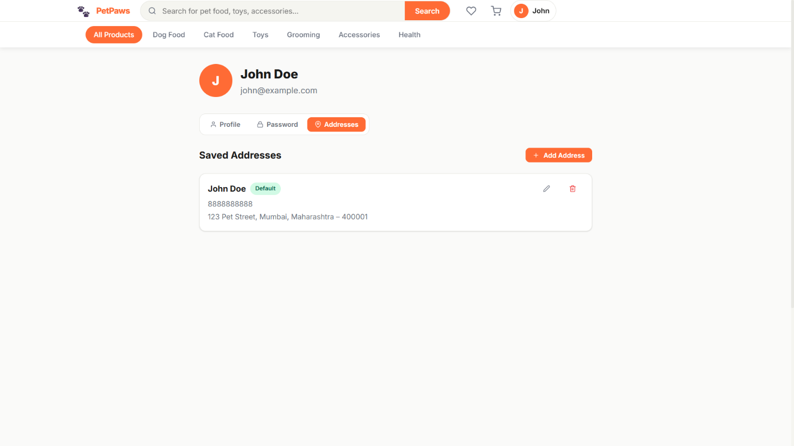

My Orders
The Orders page shows a list of order cards with status filter tabs (All, Pending, Confirmed, Shipped, Delivered, Cancelled). Each card shows Order ID, date, item count, total, product image thumbnails (up to 4), and a colour-coded status badge. Clicking any card navigates to the Order Detail page.
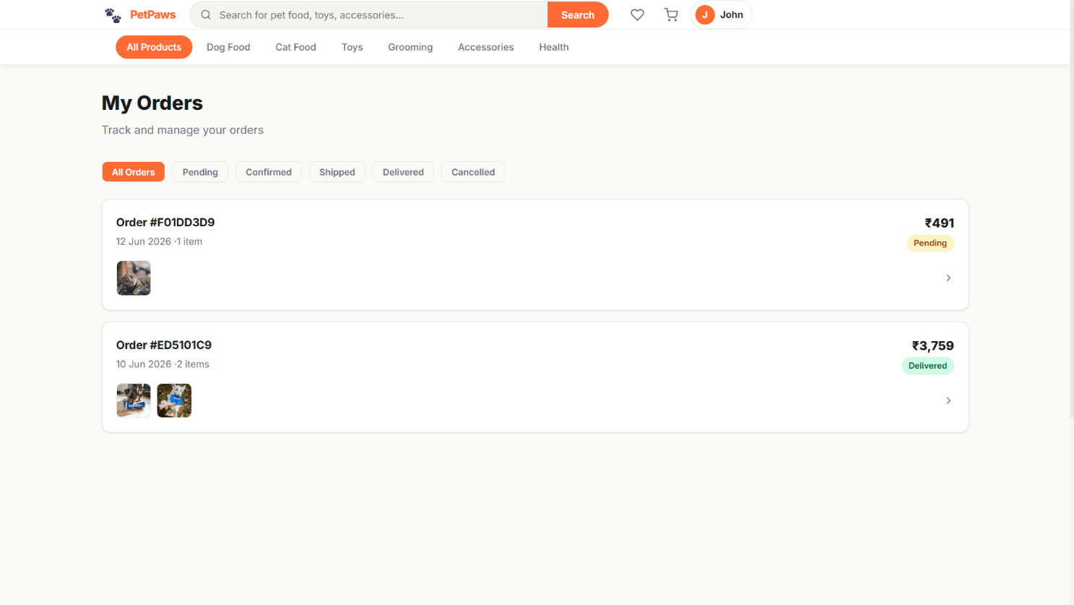

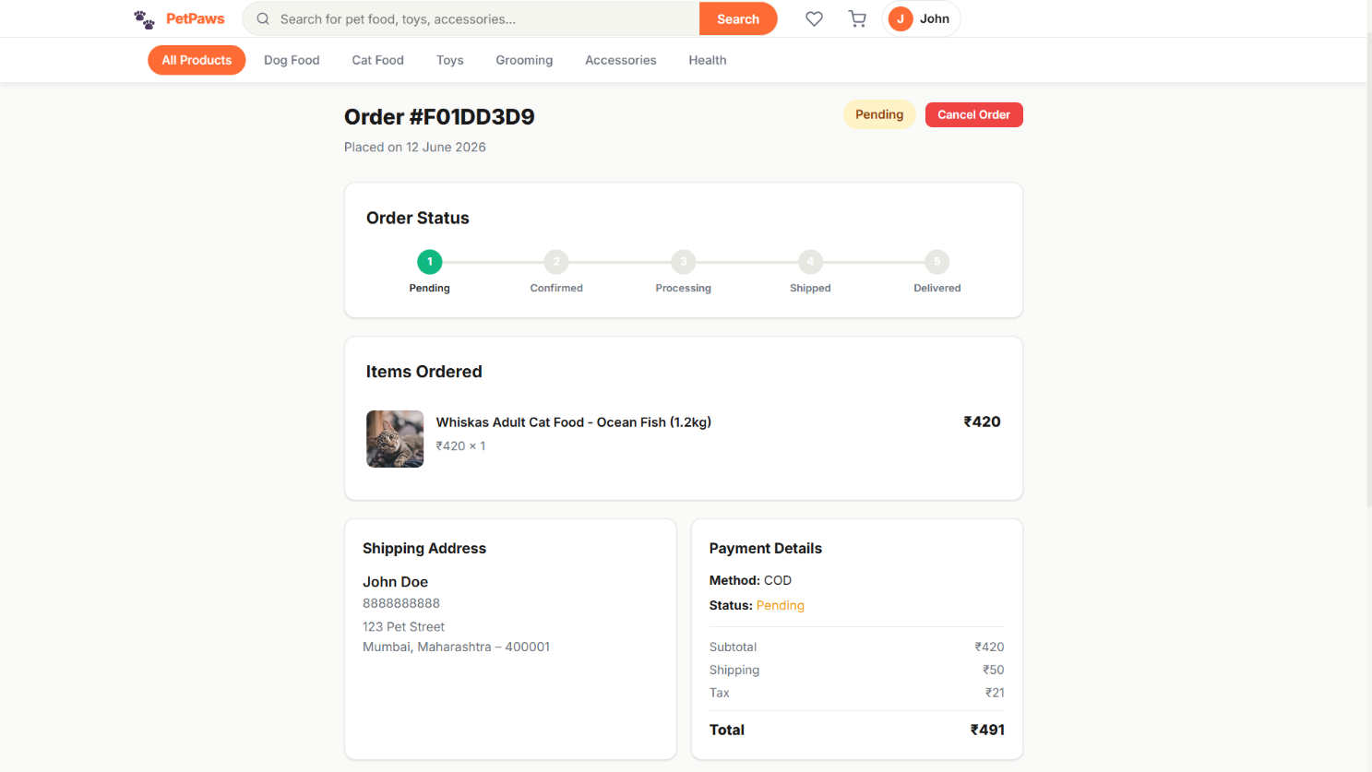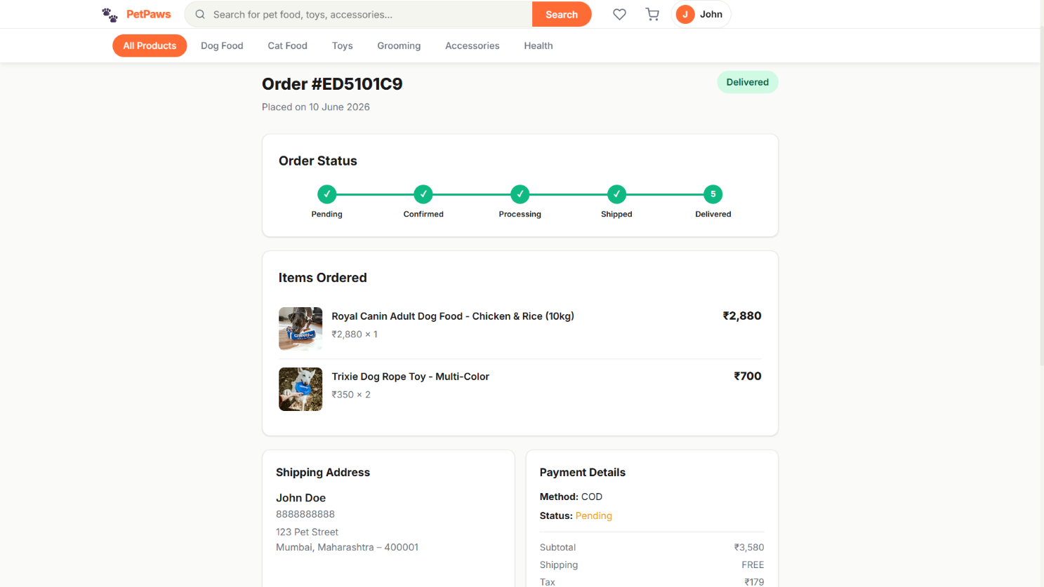

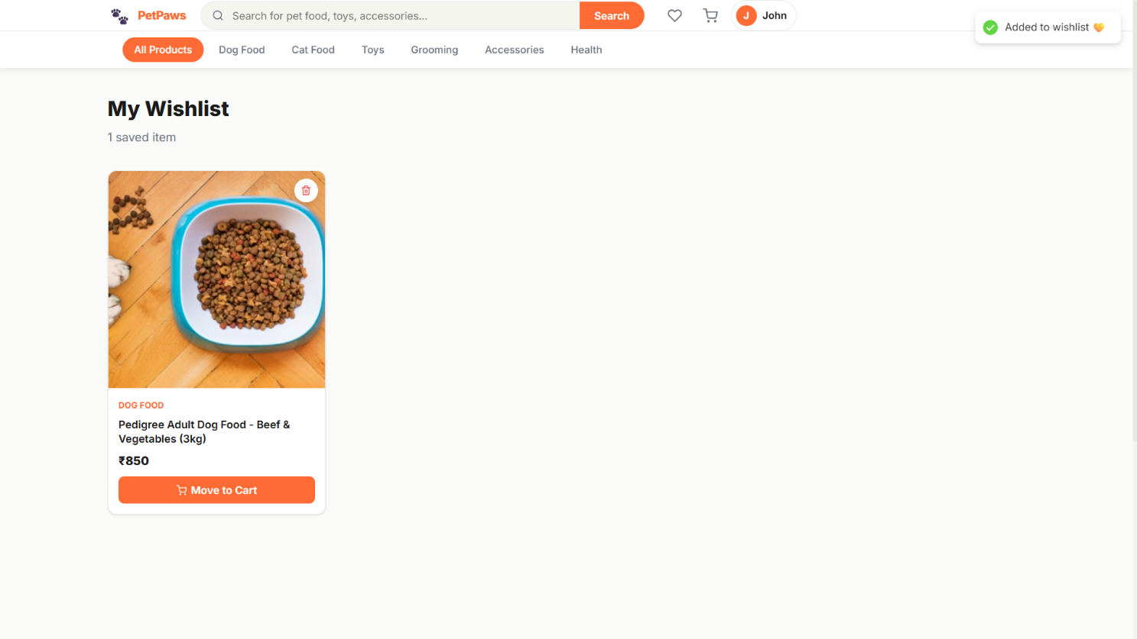

Admin Dashboard
The Admin Dashboard shows 4 KPI stat cards (Total Revenue, Total Orders, Customers, Products), a monthly revenue bar chart (bar heights proportional to revenue per month), a Low Stock Alert table, a Recent Orders quick table, and a Top Products ranking table with sold count badges.
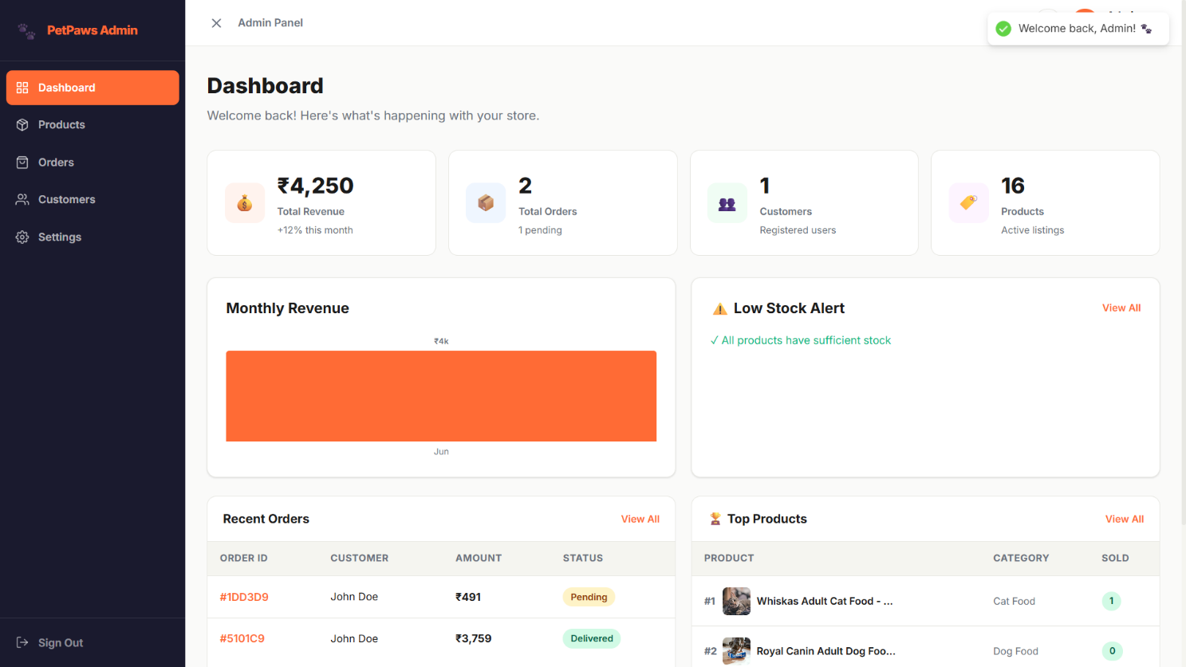
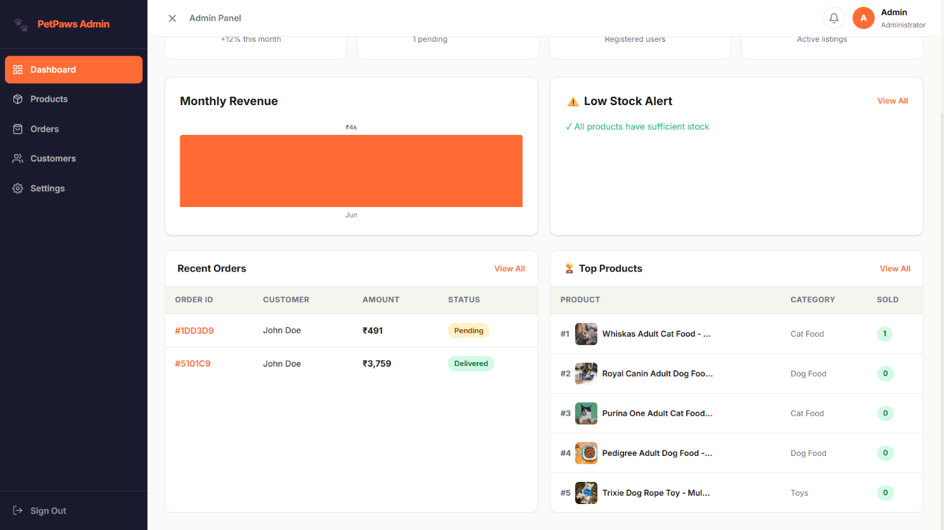

Admin Orders
The All Orders admin page shows a comprehensive table with columns: Order ID, Date, Customer (name + email), Items count, Total, Payment (method + status), Order Status badge, and a View Details eye button. Status filter tabs at the top allow filtering by order state. Each order links to a detailed management page with status update form, tracking number input, and timeline history.
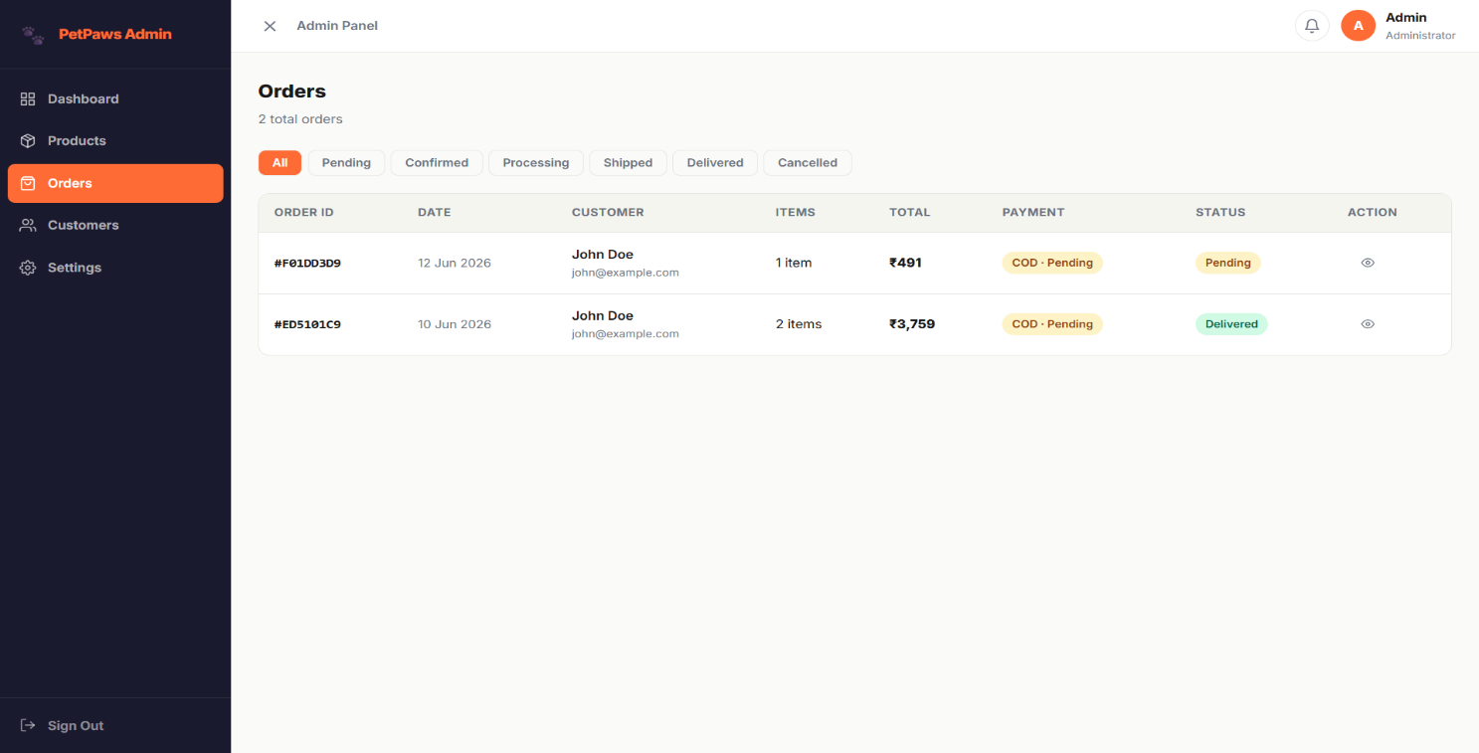
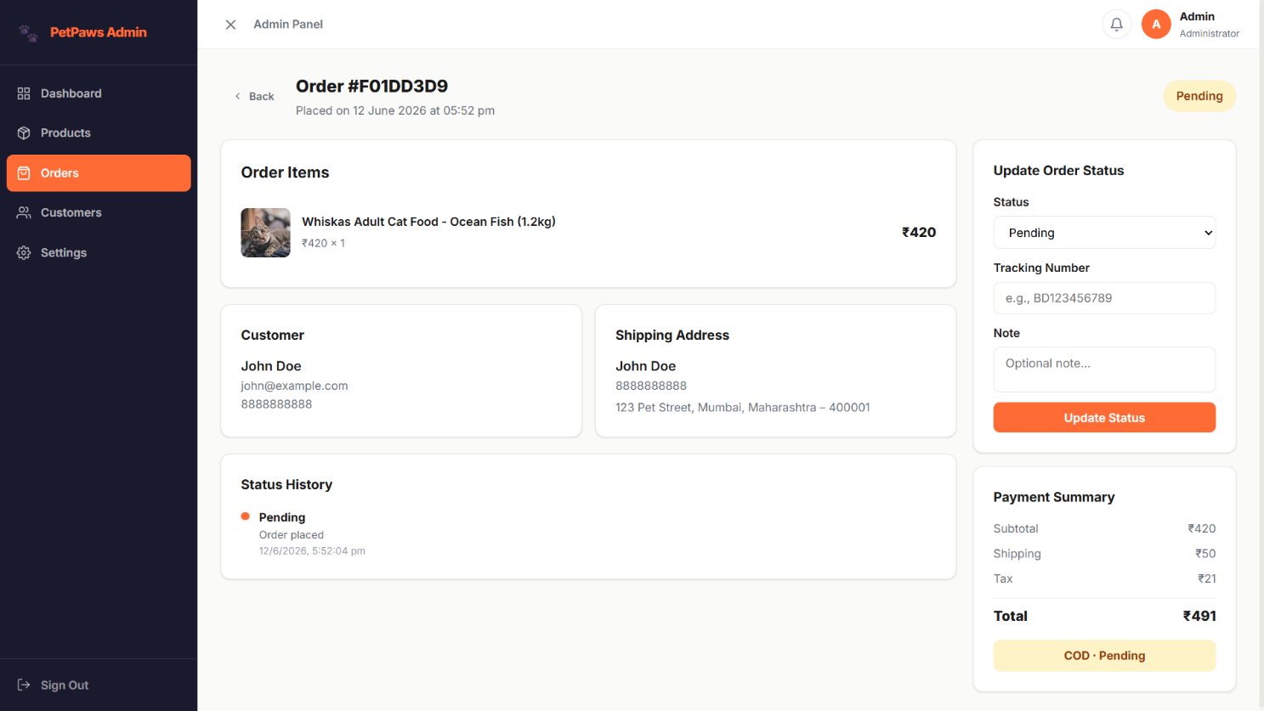

Admin Products
The All Products admin page shows a searchable product table with columns: Product (image + name + brand), Category badge, Price (with crossed-out original if discounted), Stock badge (green/yellow/red), Rating, Featured status badge, and Edit/View/Delete action buttons. An Add Product button navigates to the product form.
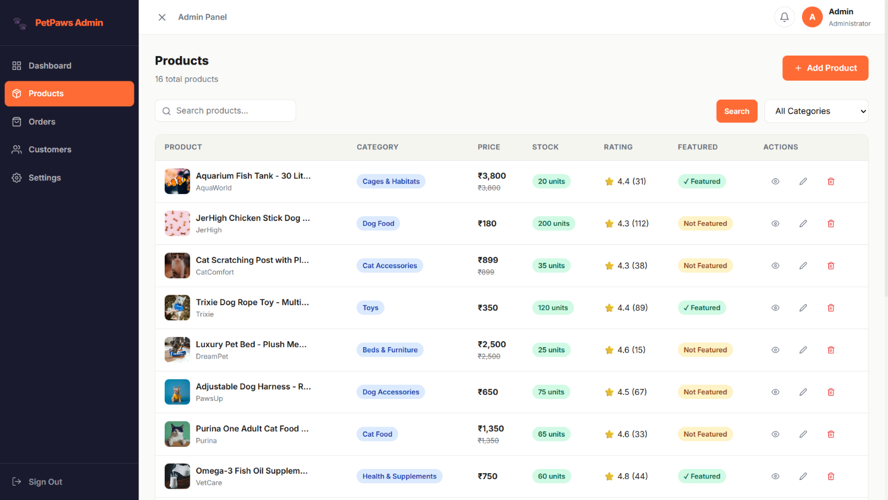

New Product Page
The Add/Edit Product form is a two-column layout. The left column contains: Basic Information (name, description, brand, weight, tags), Pricing & Stock (price, discount %, stock quantity with live discounted price preview), and Images (main image URL + additional images gallery). The right column contains: Category dropdown, Pet Type multi-select toggle buttons, and Settings (Featured toggle, Active/Visible toggle).

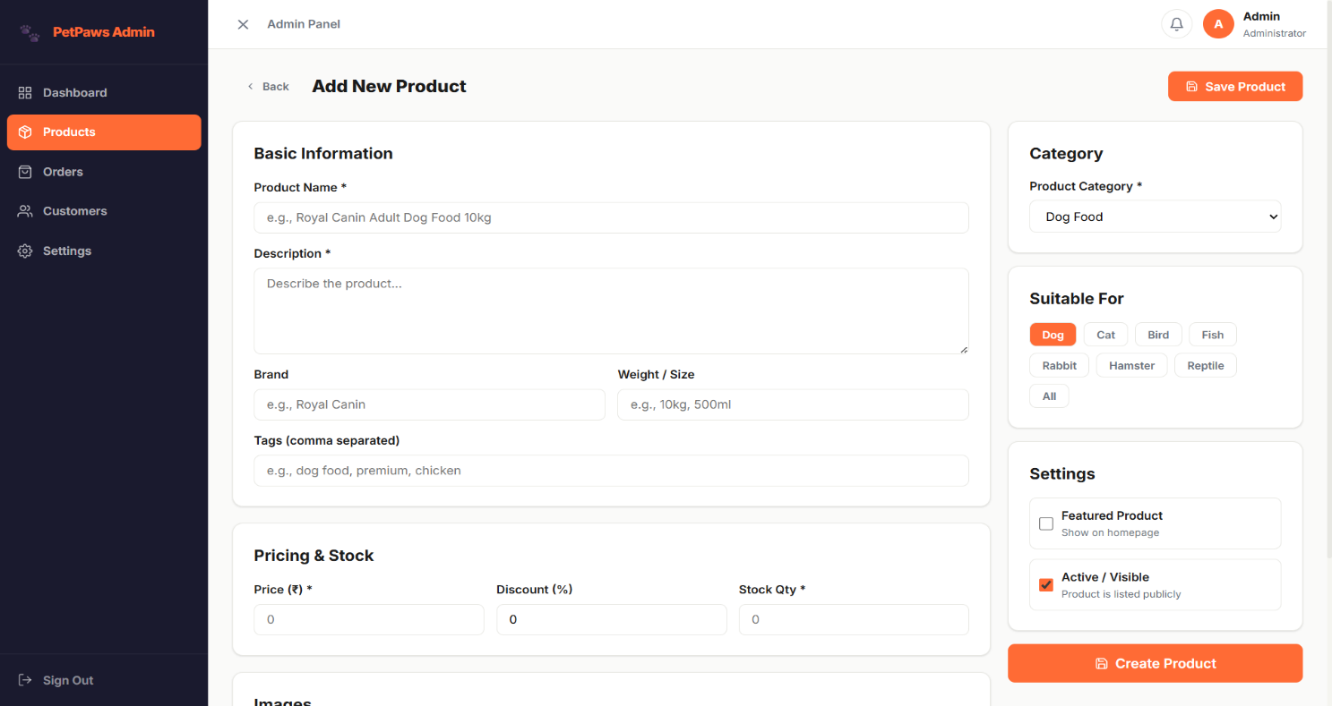

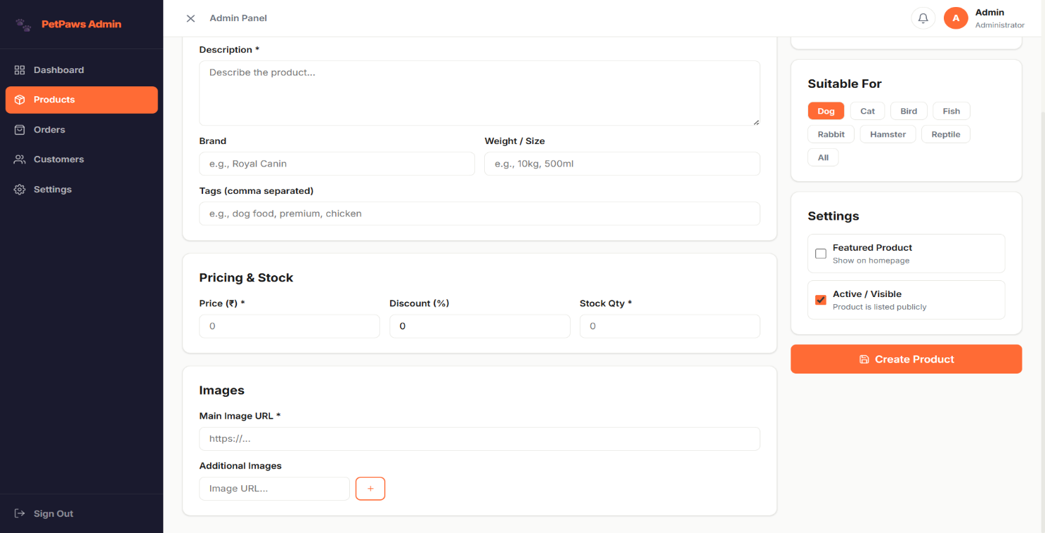
Admin Customers

The Admin Customers page displays all registered customers in a searchable table. It includes a customer search bar for filtering by name or email. The customer table shows Customer Details (name, email, avatar), Phone Number, Registration Date, Last Login Date, Number of Saved Addresses, Account Status (Active/Inactive), and Action buttons. Administrators can view customer information, monitor activity, and activate/deactivate customer accounts directly from the table.

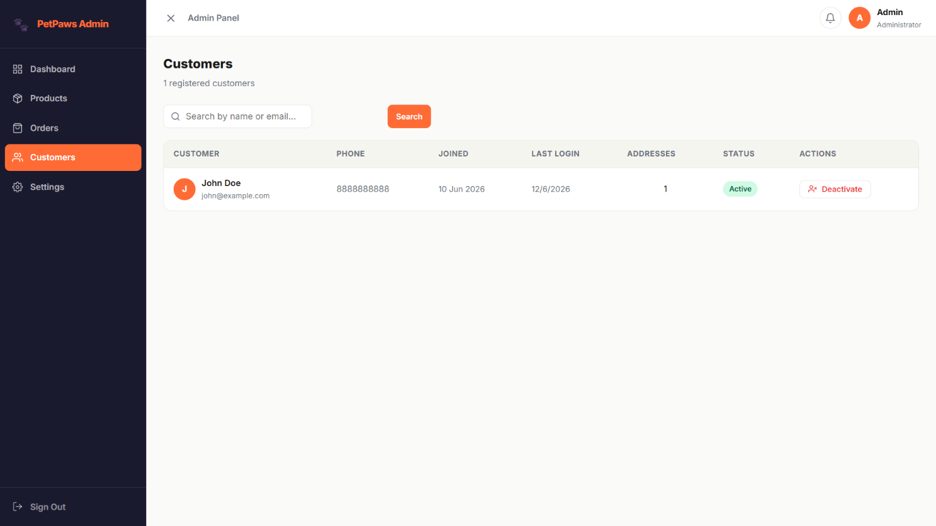

Admin Settings

The Admin Settings page provides a centralized interface for managing store-wide configurations and homepage content. Administrators can update general store information, including the store name, tagline, contact email, and phone number. The system allows configuration of shipping fees, free shipping thresholds, and applicable tax rates. Shipping and tax policies can be reviewed and modified directly from the settings panel. Homepage banners can be added, edited, enabled, disabled, or removed to manage promotional content. Banner images and redirect links can also be configured to enhance customer engagement. The category management section allows administrators to view and control product category availability. Categories can be enabled or disabled to determine their visibility on the storefront. Summary cards provide a quick overview of store information, shipping settings, active banners, and category status. All configuration changes can be saved through the settings panel, ensuring efficient administration and consistent store management.
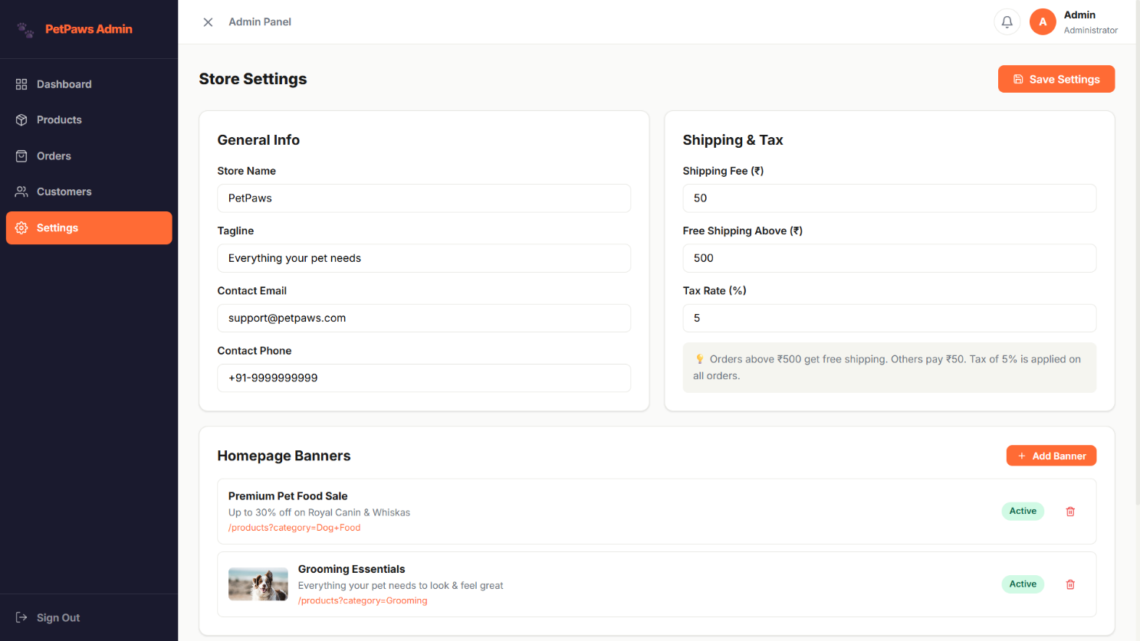

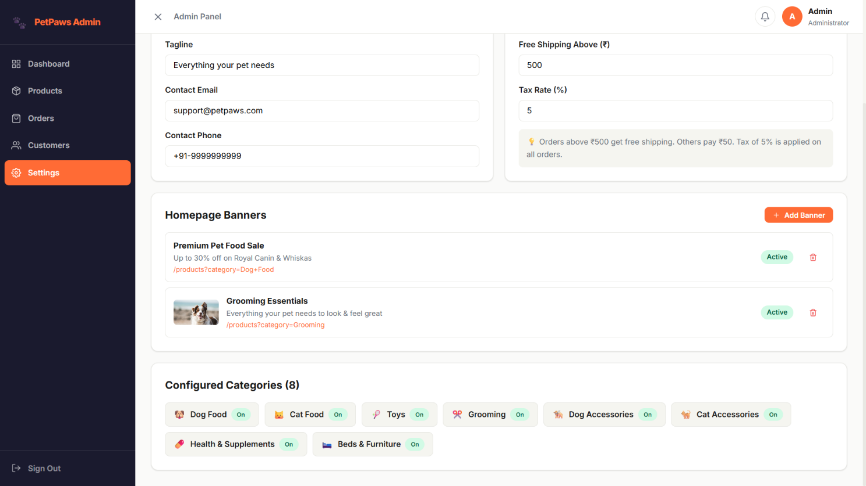

API DOCUMENTATION

Authentication Endpoints
Method | Endpoint | Description
POST /api/auth/register | Register a new user. Body: { username, email, password, phone }
POST /api/auth/login | Login user. Body: { email, password }. Returns JWT token.
POST /api/auth/admin/login | Admin-specific login. Body: { email, password }.
GET /api/auth/me | Get current authenticated user profile. Requires JWT.

Product Endpoints
Method | Endpoint | Description
GET /api/products | Get all products. Query: keyword, category, petType, brand, minPrice, maxPrice, rating, sort, page, limit, featured.
GET /api/products/featured | Get featured products for homepage display.
GET /api/products/brands | Get a distinct list of all product brand names.
GET /api/products/:id | Get single product details + reviews by product ID.
GET /api/products/:id/related | Get related products from the same category.
POST /api/products | Create a new product. Admin only.
PUT /api/products/:id | Update an existing product. Admin only.
DELETE /api/products/:id | Soft-delete a product (sets isActive: false). Admin only.

Cart Endpoints
Method | Endpoint | Description
GET /api/cart | Get the authenticated user's cart with populated product details.
POST /api/cart | Add a product to the cart. Body: { productId, quantity, variant }.
PUT /api/cart/:itemId | Update quantity of a specific cart item. Body: { quantity }.
DELETE /api/cart/:itemId | Remove a specific item from the cart by item ID.
DELETE /api/cart | Clear all items from the user's cart.

Order Endpoints
Method | Endpoint | Description
POST /api/orders | Place a new order. Validates stock, computes totals, deducts stock.
GET /api/orders/my | Get the authenticated user's order history. Query: status, page, limit.
GET /api/orders/:id | Get detailed information for a specific order.
PUT /api/orders/:id/cancel | Cancel an eligible order (Pending or Confirmed only).
GET /api/orders | Get all orders. Admin only. Query: status, page, limit.
PUT /api/orders/:id/status | Update order status. Admin only. Body: { status, note, trackingNumber }.

CONCLUSION
PetPaws successfully demonstrates a complete, production-ready MERN stack e-commerce application tailored for the pet foods and accessories domain. The project covers all the essential modules of a modern online store — from product discovery and cart management to secure checkout, order tracking, and a comprehensive admin panel.

The application is built following industry best practices including the MVC architectural pattern, JWT-based stateless authentication, MongoDB aggregation for analytics, React Context API for global state management, and responsive CSS design with mobile-first considerations.

Key achievements of the PetPaws project:
- Full-Stack Integration: Seamless communication between the React frontend and the Express.js backend via Axios with JWT interceptors.
- Domain Specificity: All 15 product categories, 8 pet types, and sample data are specifically designed for the pet store domain.
- Security: Passwords are bcrypt-hashed, routes are protected with JWT middleware, and admin routes have role-based access control.
- Scalability: The modular folder structure (models, controllers, routes) makes it straightforward to add new features, categories, or payment providers.
- User Experience: From animated hero carousels to hover-effect product cards, multi-step checkout, and real-time order tracking — the UI prioritizes a smooth and delightful shopping experience for pet owners.

PetPaws can be further extended with features such as real payment gateway integration (Razorpay, PayU), email notifications via Nodemailer, product image upload via Cloudinary, and deployment on platforms like Vercel (frontend) and Railway (backend) for a fully live production application.

Demo Credentials:
Role | Email | Password
Administrator | admin@petpaws.com | admin123
Registered User | john@example.com | user123

Project Code & Source Files:
- Full source code included in the project ZIP archive: petpaws-mern-app.zip
- Backend: /server — Node.js + Express.js + MongoDB
- Frontend: /client — React.js + Vite
- Seed script: /server/data/seeder.js — Run with: npm run seed

